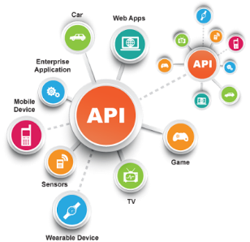**SE495 Software and Systems Integration**

**Chapter 3: Enterprise Resource Planning (ERP) Project**

**Project Title: Implementing a Simple ERP System for a Retail Business**

**Objective**

The primary objective of this project is for students to design and implement a simple ERP system for a retail business to manage its sales, inventory, and suppliers. Students will gain hands-on experience in building an ERP system from scratch, using business process models to capture integration requirements, and leveraging service-oriented architecture to build integration solutions.

**Project Requirements**

1. Design and implement a simple ERP system for a retail business.
2. Create a business process model to capture integration requirements.
3. Implement a service-oriented architecture for the ERP system.
4. Demonstrate the system's ability to manage sales, inventory, and suppliers.

**Project Steps**

1. **Understand the business domain:** Research and understand the retail business domain, focusing on the processes involved in sales, inventory management, and supplier relationships.
2. **Identify the integration requirements:** Based on the understanding of the retail business domain, identify the integration requirements for sales, inventory, and suppliers.
3. **Create a business process model:** Develop a business process model that captures the integration requirements for sales, inventory management, and supplier relationships. Use a modeling tool like BPMN or UML to create the diagrams.
4. **Design the ERP system architecture:** Design the overall architecture of the ERP system, leveraging service-oriented architecture principles. Break down the system into smaller services that interact with each other.
5. **Implement the ERP system:** Choose a programming language or framework to build the ERP system. Implement the services identified in the architecture design phase.
6. **Test the ERP system:** Test the ERP system to ensure it meets the integration requirements for sales, inventory management, and supplier relationships.
7. **Present your solution:** Prepare a presentation or report outlining the ERP system's design, implementation, and test results. Demonstrate how the system manages sales, inventory, and suppliers efficiently.